DEPARTMENT OF MECHANICAL ENGINEERING, IIT KANPUR

DATE OF EXPERIMENT – February 10, 2017

DATE OF SUBMISSION – February 17 , 2017

EXPERIMENT 3

FATIGUE

ME 222 – STRUCTURE AND PROPERTIES OF MATERIALS

MATERIALS LABORATORY

**GROUP – A3**

1. AVINASH KUMAR 150169
2. ­­­­­­­­ARVIND KUMAR PRASAD 150141
3. ASHISH KUMAR YADAV 150148
4. ASIM KATAKWAR 150159
5. ATUL BIMBRAHW 150162
6. AYUSH SINGH 150177
7. BHANUPRATAP NIRANJAN 150182

**INTRODUCTION**

The main purpose of the experiment is the study for failure behavior of the given specimen.

Fatigue behavior is observed for cyclic loading and unloading

In this experiment we use mild Steel specimen fortensile loading.

There are four methods by which one can check the fatigue behavior of the given specimen.

1. Reversed bending

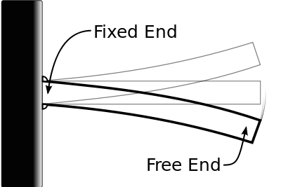

1. Rotating bending

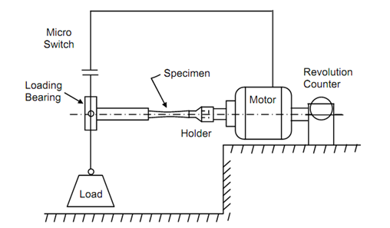

1. Reversed torsional loading

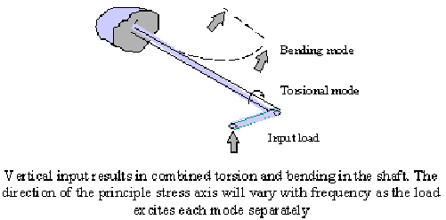

1. Reversed axial loading

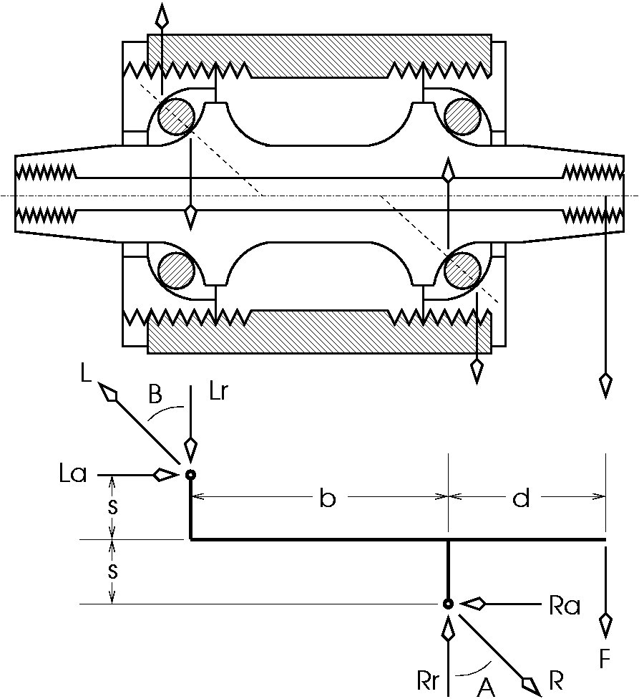

**OBJECTIVES**

The objectives for this experiment is as follows

1. Fatigue strength at a specified number of cycles
2. To study the effect of fluctuating stress.

The main motive of the experiment is determining the life cycle of a material and to obtain the S-N curve for the sample of mild steel.

And to understand the methodology of fatigue testing.

**THEORY**

**Fatigue**

It is a type of failure that happens due to repeated stress or strain cycles over a longer period of time. Basically, the stresses are dynamic and fluctuating. Thus, failure generally occurs at a stress level that is substantially lower than the yield (or tensile) strength for a static load. Also, the applied tensile stress direction is generally orthogonal to the fracture surface developed.

**Cyclic stresses**

They can be represented by their time dependence which is steady and sinusoidal. There exists a symmetry of stress amplitude($σ_{a}$) about a mean stress ($σ_{m}$) level. The maximum stress($σ_{max}$) and minimum stress($σ_{min}$) levels may be symmetrical or asymmetrical to the zero stress level; in case of symmetrical( called reversed stress cycle ), mean stress level = zero stress level, whereas, in case of asymmetrical( called repeated stress cycle ), mean stress level may be positive or negative( probability of fatigue in case of tensile stress is higher than compressive stress ), but cannot be equal to zero.

$$σ_{m}=\frac{σ_{max}+ σ_{min}}{2}$$

Range of stress, $σ_{r}= σ_{max}- σ_{min}$

$$σ_{a}=\frac{σ_{r}}{2}=\frac{σ_{max}- σ_{min}}{2}$$

Stress ratio, $R=\frac{σ_{min}}{σ_{max}}$

**Fatigue limit**

It is the maximum value of fluctuating stress (stress amplitude) for which failure will never occur for any 'no. of cycles' value(i.e. failure will not be caused for infinite no. of cycles).

**Fatigue strength**

It is the stress level for the occurrence of failure at specified no. of cycles.

**Fatigue life ($N_{f}$)**

It is defined as the no. of cycles for a specified stress level that cause failure.

S-N curve is the curve between stress amplitude ($σ_{a}$) and no. of cycles (N), analyzing which we can deduce the values of fatigue limit, fatigue strength and fatigue life.

**PROCEDURE**

* Analyze the surface of the sample carefully to detect any surface imperfections or marks formed due to machining
* Smoothen the mild steel sample surface by polishing it
* Discard the sample having any defects or imperfections as these may initiate a fracture
* Measure the dimensions of the mild steel sample having no surface imperfections
* Mount the mild steel sample tightly in the sample holder to ensure that it passes through the opening provided in the rod on which the loads are attached and the rubber gets affixed
* perfectly to the holder
* Attach the desired load on the rod after fixating the specimen
* Switch on the fatigue testing machine and carry out the fatigue test by recording the number of cycles for the failure

**SPECIMEN DATA**

The specimen used in the experiment has dog-bone shape made of mild steel and the dimensions are according to the ASTM / ARE standards.

**FATIGUE TESTING MACHINE**

The major parts of machine:

1. Motor-2800 rev/min
2. 110 voltage ac power supply
3. Revolution counter and weight holders

**DATA SHEET**

**Work-piece specifications**

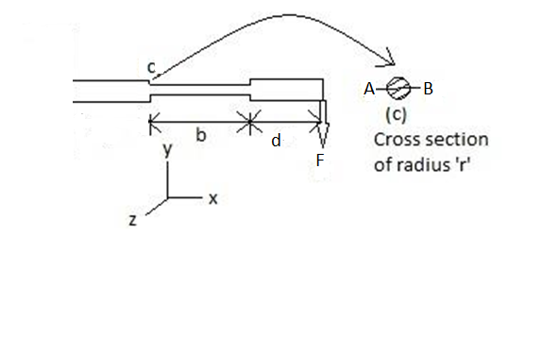

Inner diameter = 6.08 ± 0.02

**Machine Specifications**

* AC induction motor
* 0.5 H.P
* Phase1
* 220 volts

**CALCULATIONS**

Force (f) = 4x9.8 N = 39.2 N

Moment (m) = 39.2 x225 x 10^ (-3) = 8.82 Nm

Inertia about AB (I) = (pi*r4)/4

Maximum compressive/tensile stress (σmax)= (M x r)/I

= 384.35 MN/m2

σmin = -384.35 MN/m2

σmean =0

σr = 384.35-(-384.35) MN/m2 = 768.70 MN/m2

σa = σr /2 = 384.35 MN/m2

**OBSERVATIONS**

|  |  |  |
| --- | --- | --- |
| Force Applied(Kg-f) | Engineering Stress (MPa) | Cycles to failure (N) |
| 4 | 384.35 | 3500 |
| 3.5 | 336.31 | 3340 |
| 3 | 288.26 | 6850 |
| 2.5 | 240.22 | 1450 |
| 2 | 192.18 | 30720 |

**Stress vs LogN**

**RESULTS**

* The mild steel rod in bending fatigue machine failed after 30720 cycles under application of 2kgf load.
* On certain extrapolation, we can safely say that at around 1.5-1.7 kgf load ( for 50-60 MPa stress values), we can achieve endurance limit in an approximate sense.
* Nonetheless, the curve obtained for stress versus no. of cycles matches with the curve of ductile material qualitatively.

**DISCUSSION AND CONCLUSIONS**

* The no. of cycles found for the mild steel rod is quite less than the tabulated experimental data which could be because of following reasons:
  + Repetitive loading has been done previously on the same specimen before.
  + The rpm of the motor may have exceeded its nameplate ratings.
* We can conclude from the achieved values that below a certain endurance limit, the rod will never fail under the repetitive loading and compression conditions.
* In this experiment, the mean stress is equal to zero, hence, the no. of cycles are larger than it would have been for non-zero mean stress.
* The fatigue takes place from the location of stress concentrators, i.e. on the left most side of rod close to revolving center. So, in order to avoid failure of materials, we must avoid the presence of stress concentrators by making transitions in cross-sectional area smooth.

**PRECAUTIONS / SOURCES OF ERROR**

* Mild steel rod must be properly held in the holder so that it does not come out during the experiment.
* Care should be taken and a safe distance should be maintained from them while handling the machine.
* Machine should be stopped after one reading for some time interval to dissipate heat.

**BIBLIOGRAPHY**

* Materials Science and Engineering, An Introduction (Eighth Edition) by William D. Callister, Jr. and David G. Rethwisch.
* Class Notes Structure and Properties of Materials, ME 222A
* Wikipedia